| Experiment No.6 |
| --- |
| Serialization in python using Pickle |
| Date of Performance: |
| Date of Submission: |

**Aim**: Serialization in python using Pickle

**Objective:** To introduce basic concept of Pickle module

**Theory**:

* What is Serialization?
* Serialization is the process of converting a Python object into a byte stream that can be stored in a file or transmitted over a network.
* What is Pickle?
* Pickle is a Python module used for serializing and deserializing Python objects.
* Why Pickle?
* Pickle provides a convenient way to save Python objects to disk and load them back into memory later.
* How to use Pickle?
* The pickle module provides two main functions: dump() for serialization and load() for deserialization.

1. **pickle.dump(obj, file)**:

* The **pickle.dump()** function is used to serialize a Python object **obj** and write it to a file specified by the file object **file**.
* This function takes two parameters:
  + **obj**: The Python object to be serialized.
  + **file**: A file object opened in binary write mode ('wb') where the serialized data will be written.

1. **pickle.load(file)**:

* The **pickle.load()** function is used to deserialize data from a file specified by the file object **file** and reconstruct the original Python object.
* This function takes one parameter:
  + **file**: A file object opened in binary read mode ('rb') from which the serialized data will be read and deserialized.

**Code:-**

import pickle

class employee:

pass

f= open('employee.dat','wb')

n= int(input('How many employees ?'))

for i in range(n):

id= int(input('Enter the id'))

name= input('Enter name: ')

sal=float(input('Enter salary: '))

e=employee()

e.id = id

e.name-name

e.salary = sal

pickle.dump(e,f)

f.close()

**Output:-**

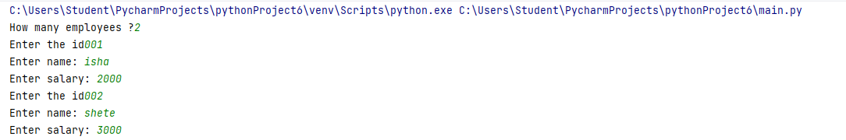

**Conclusion:** By using the concept of Serialization in Python we have performed the operation based on Pickle. In the above program a class is created named as employee in which employee id,name and salary is taken from the user and stored in object e. After that by using dump() function the content of e is dumped into file f and then we get the above output.